Task 1

Login.html

<!DOCTYPE html>

<html lang="en">

<head>

<meta charset="UTF-8">

<meta name="viewport" content="width=device-width, initial-scale=1.0">

<title>Login</title>

</head>

<body>

<h1>Log in</h1>

<form action="./loginrespons.html" method="get">

<fieldset>

<legend><b>Enter login details</b></legend>

<dl>

<dt>

<label for="user">username</label>

</dt>

<dd>

<input type="text" id="user" placeholder="Enter username">

</dd>

<dt>

<label for="pass">password</label>

</dt>

<dd>

<input type="text" id="pass" placeholder="Enter password">

</dd>

<br>

<dd><input type="submit" value="Login"></dd>

</dl>

</fieldset>

<a href="./register.html">Creat an account</a>

</form>

</body>

</html>

Output

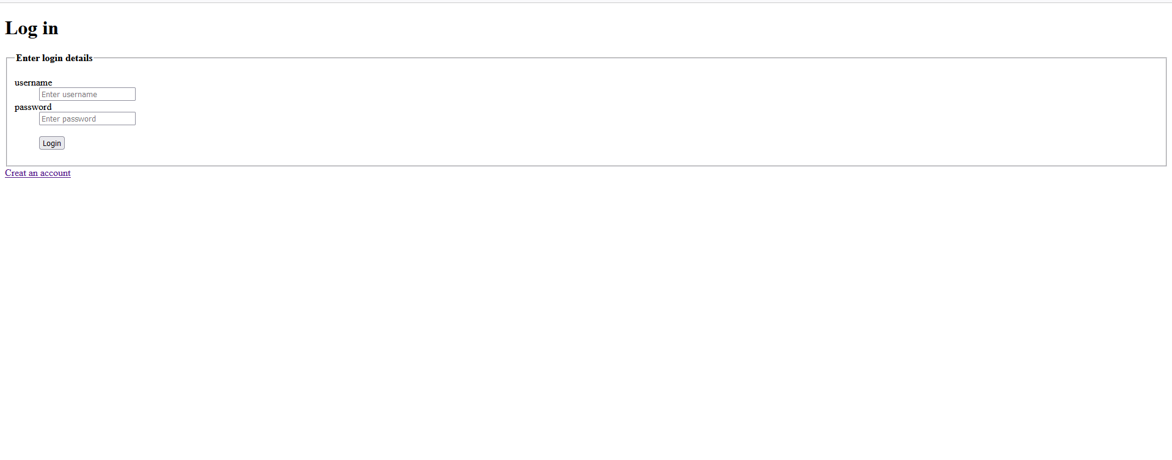

Registration.html:

<!DOCTYPE html>

<html lang="en">

<head>

<meta charset="UTF-8">

<meta name="viewport" content="width=device-width, initial-scale=1.0">

<title>Registration</title>

</head>

<body>

<center>

<h1>Registration page</h1>

<fieldset>

<legend><b>Enter your details</legend>

<form action="./response.html">

<dl>

<dt>

<label for="name">your name</label>

</dt>

<dd>

<input type="text" id="name" placeholder="Enter your name">

</dd>

<dt>

<label for="mail">your mail</label>

</dt>

<dd>

<input type="text" id="mail" placeholder="Enter your mail">

</dd>

<dt>

<label for="user">user name</label>

</dt>

<dd>

<input type="text" id="user" placeholder="Enter username">

</dd>

<dt>

<label for="pass">password</label>

</dt>

<dd>

<input type="text" id="pass" placeholder="Enter password">

</dd>

<br>

<dt>

<input type="submit" value="Register">

</dt>

</dl>

</form>

</fieldset>

</center>

</body>

</html>

Output

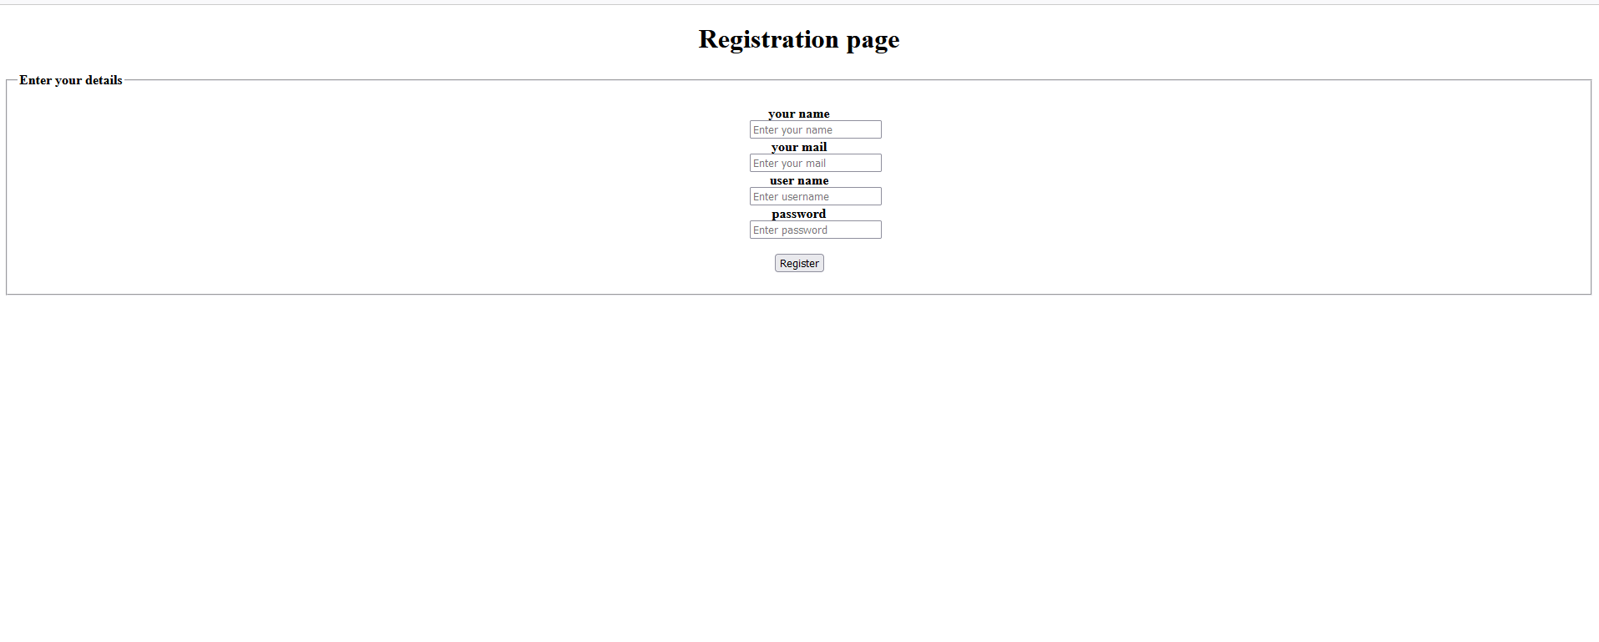Response.html:

<!DOCTYPE html>

<html lang="en">

<head>

<meta charset="UTF-8">

<meta name="viewport" content="width=, initial-scale=1.0">

<title>Registration Sucessfull</title>

</head>

<body>

<center>

<h1>Registration Sucessfull</h1>

<form action="./loginrespons.html">

<fieldset>

<legend><b>Enter login details</b></legend>

<dl>

<dt>

<label for="user">username</label>

</dt>

<dd>

<input type="text" id="user" placeholder="Enter username">

</dd>

<dt>

<label for="pass">password</label>

</dt>

<dd>

<input type="text" id="pass" placeholder="Enter password">

</dd>

<br>

<dd><input type="submit" value="Login"></dd>

</dl>

</fieldset>

</form>

</center>

</body>

</html>

Output

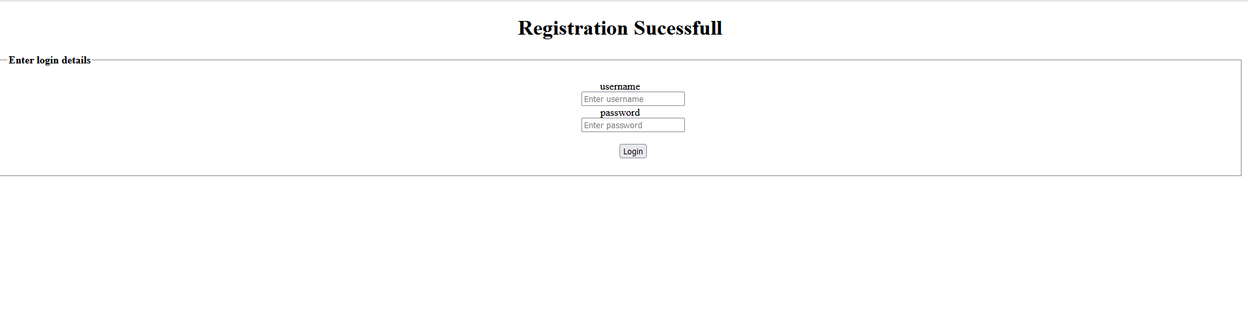

Loginresponse.html:

<!DOCTYPE html>

<html lang="en">

<head>

<meta charset="UTF-8">

<meta name="viewport" content="width=, initial-scale=1.0">

<title>Document</title>

</head>

<body>

<h1>Loged Sucessfull</h1>

</body>

</html>

Output

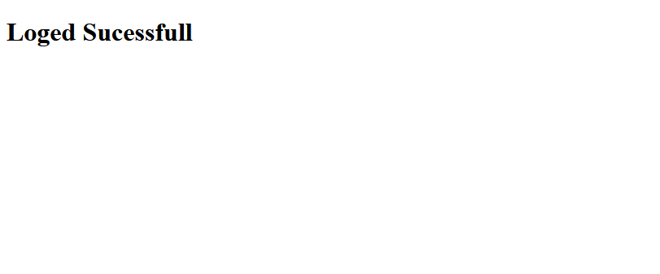

Task 2

<!DOCTYPE html>

<html lang="en">

<head>

<meta charset="UTF-8">

<meta name="viewport" content="width=, initial-scale=1.0">

<title>Telangan bus pass</title>

</head>

<body>

<center>

<h1>TELANGAN STATE ROAD TRANSPORT CORPORATION</h1>

<h2>GENERAL BUS PASS APPLICATION</h2>

<form action="./sucessfull.html">

<fieldset>

<legend>Applicant Details</legend>

<label for="Name">Name:</label>

<input type="text" id="Name" placeholder="Enter Name" required>

<label for="dod">Date of Birth:</label>

<input type="text" id="dod" required placeholder="Enter Date of Birth">

<br>

<label for="mobile">Mobile no:</label>

<input type="text" id="mobile" placeholder="Enter Mobile no">

<label for="Father">Father Name:</label>

<input type="text" id="Father" placeholder="Enter Father Name"><br>

<label for="adhar">Adhar no:</label>

<input type="text" id="adhar" placeholder="Enter Adhar no">

<label for="Mail">Mail id</label>

<input type="text" id="Mail" placeholder="Enter mail id">

</fieldset>

<fieldset>

<legend>Residental Address</legend>

<dl>

<dt>

<label for="Residental">Residental Adress</label>

</dt>

<dd>

<input type="text" id="Residental" placeholder="Enter Residental Adress">

</dd>

<br>

<dt>

<label for="Pin">Pincode</label>

</dt>

<dd>

<input type="text" id="Pin" placeholder="Enter pincode">

</dd>

</dl>

</fieldset>

<fieldset>

<legend>Pass Type Details</legend>

<dl>

<dt>

<label for="City">City</label>

</dt>

<dd>

<select name="City" id="City">

<option value="Hyderabad">Hyderabad</option>

<option value="Warangal">Warangal</option>

</select>

</dd>

<dt>

<label for="Pass">Pass Type</label>

</dt>

<dd>

<select name="Pass Type" id="Pass">

<option value="General Pass">Greater Pass</option>

<option value="General Ordinary route Pass">General Ordinary route Pass</option>

</select>

</dd>

</dl>

</fieldset>

<br>

<input type="submit" value="submit">

</form>

</center>

</body>

</html>

Output

